IAM (Identity Access & Management Service)
AWS Identity and Access Management (IAM) enables you to manage access to AWS services and resources securely. Using IAM, you can create and manage AWS users and groups, and use permissions to allow and deny their access to AWS resources. IAM can also keep our account credentials private.
- All our employees cannot use one single user for all employee unique user needs to be there. Using this we can create different users.
- In organization we don’t have root user access. We always have a IAM user. For each employee there is separate IAM user we have.
- IAM is a shared access is shared access you can share your AWS account with multiple people by using IAM service.
- This service is free of cost service.
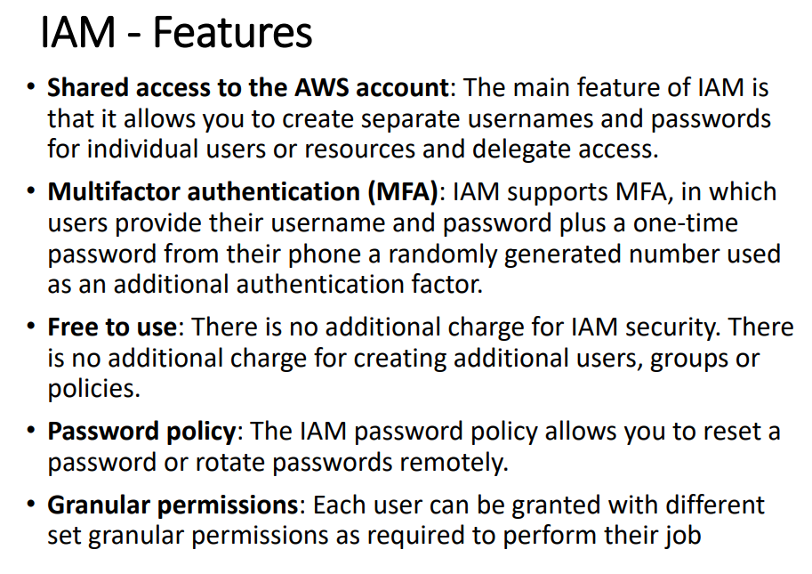
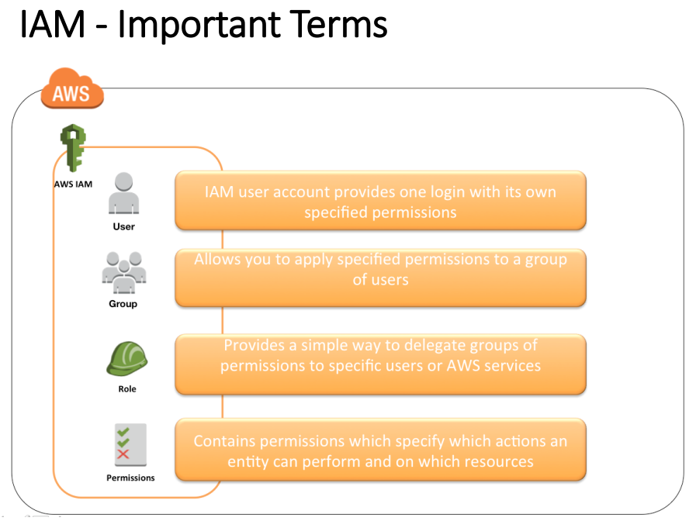

There are 2 types of accounts in AWS
- Root user
• Root Account Credentials are the email address and password with which we sign in into the AWS account
• Root Credentials has full unrestricted access to AWS account including the account security credentials which include sensitive information. Our root users cannot have all permissions but lots of permission.
• An Administrator account can be created for all the activities which too has full access to the AWS account except the accounts security credentials, billing information and ability to change password

- IAM user
• IAM user represents the person who is creating or service who uses the access to interact with AWS.
• IAM user starts with no permissions and is not authorized to perform any AWS actions on any AWS resources and should be granted permissions as per the job function requirement.
• Each IAM user is associated with one and only one AWS account.
• IAM User cannot be renamed from AWS management console and has to be done from CLI or SDK tools.
• IAM is global service whichever user you are going to create he can work on all the regions.

How to create IAM user?
Sign in to aws console search for IAM(IAM is global service) click on users create users give name to your user 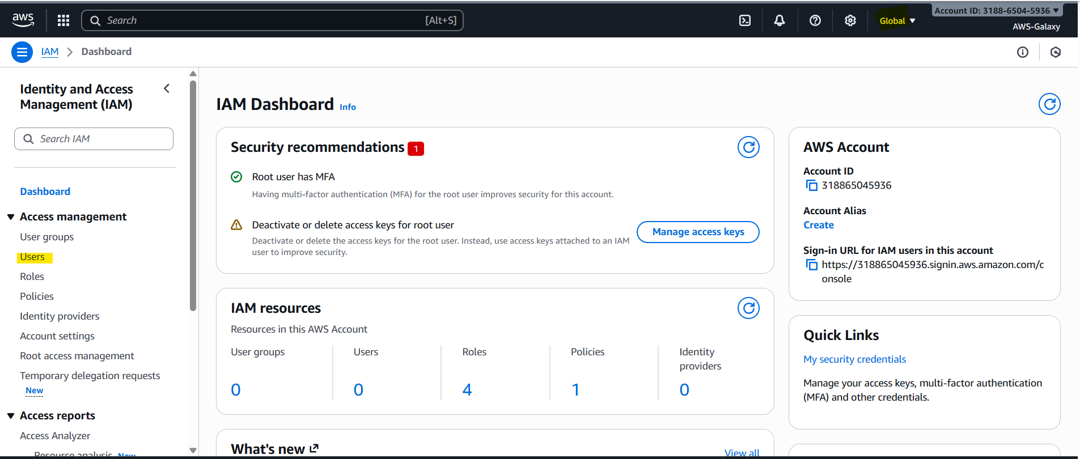
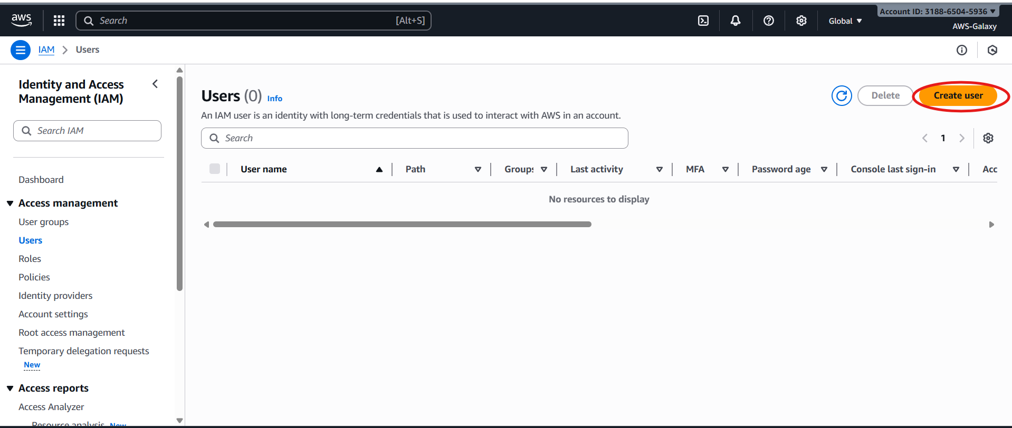
There are multiple ways user can login like aws console, CLI. If you want to login user by using console check highlighted checkbox.

Next you have select Password how you want to give. Autogenerated means system will generate random password and custom means you can provide it.
If you select “Users must create a new password at next sign-in – Recommended” this checkbox user will get by default one permission to change the password “ IAMUserChangePassword IAMUserChangePassword “. If you uncheck the checkbox user cannot change the password.
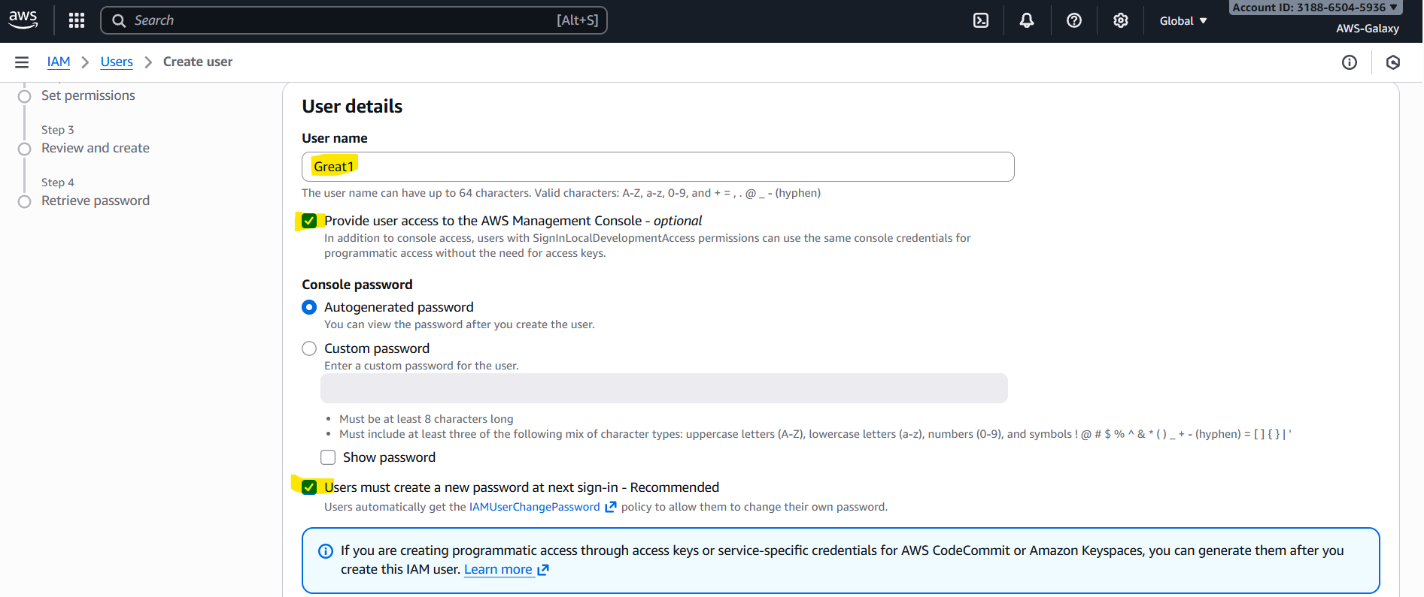
Then click on next
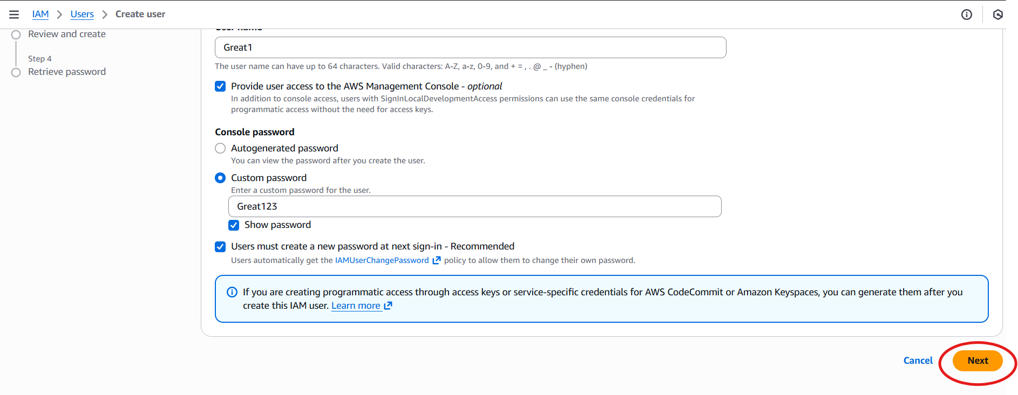
Here you can give different permissions to your users. There are 3 ways to give permission to IAM users:
1. Add user to group
- What it does: Lets you place the new user into an existing IAM group.
- How permissions are given: The user inherits all policies attached to that group.
- Best use case: Team-based management. For example, all developers in the DevOps group automatically get EC2 and S3 access.
- Interview tip: This is the most scalable and recommended option.

2. Copy permissions from existing user
- What it does: Clones the policies of another IAM user and applies them to the new one.
- How permissions are given: The new user gets the same set of policies (direct, group, or role-based) as the selected user.
- Best use case: Quick setup when onboarding someone with identical responsibilities.
- Interview tip: Convenient but not flexible — can lead to over-provisioning if copied blindly.

3. Attach policies directly
- What it does: Lets you attach IAM policies (like AmazonS3ReadOnlyAccess) directly to the user.
- How permissions are given: The user gets only the policies you select.
- Best use case: For unique, one-off permissions that don’t fit group structures.
- Interview tip: Not recommended for large environments because it’s harder to manage at scale.
- There below you will be able to see all permissions. Where type is mentioned as AWS managed this means this are the default permissions we are getting it from AWS. But wherever you see customer managed this are we have created permissions.

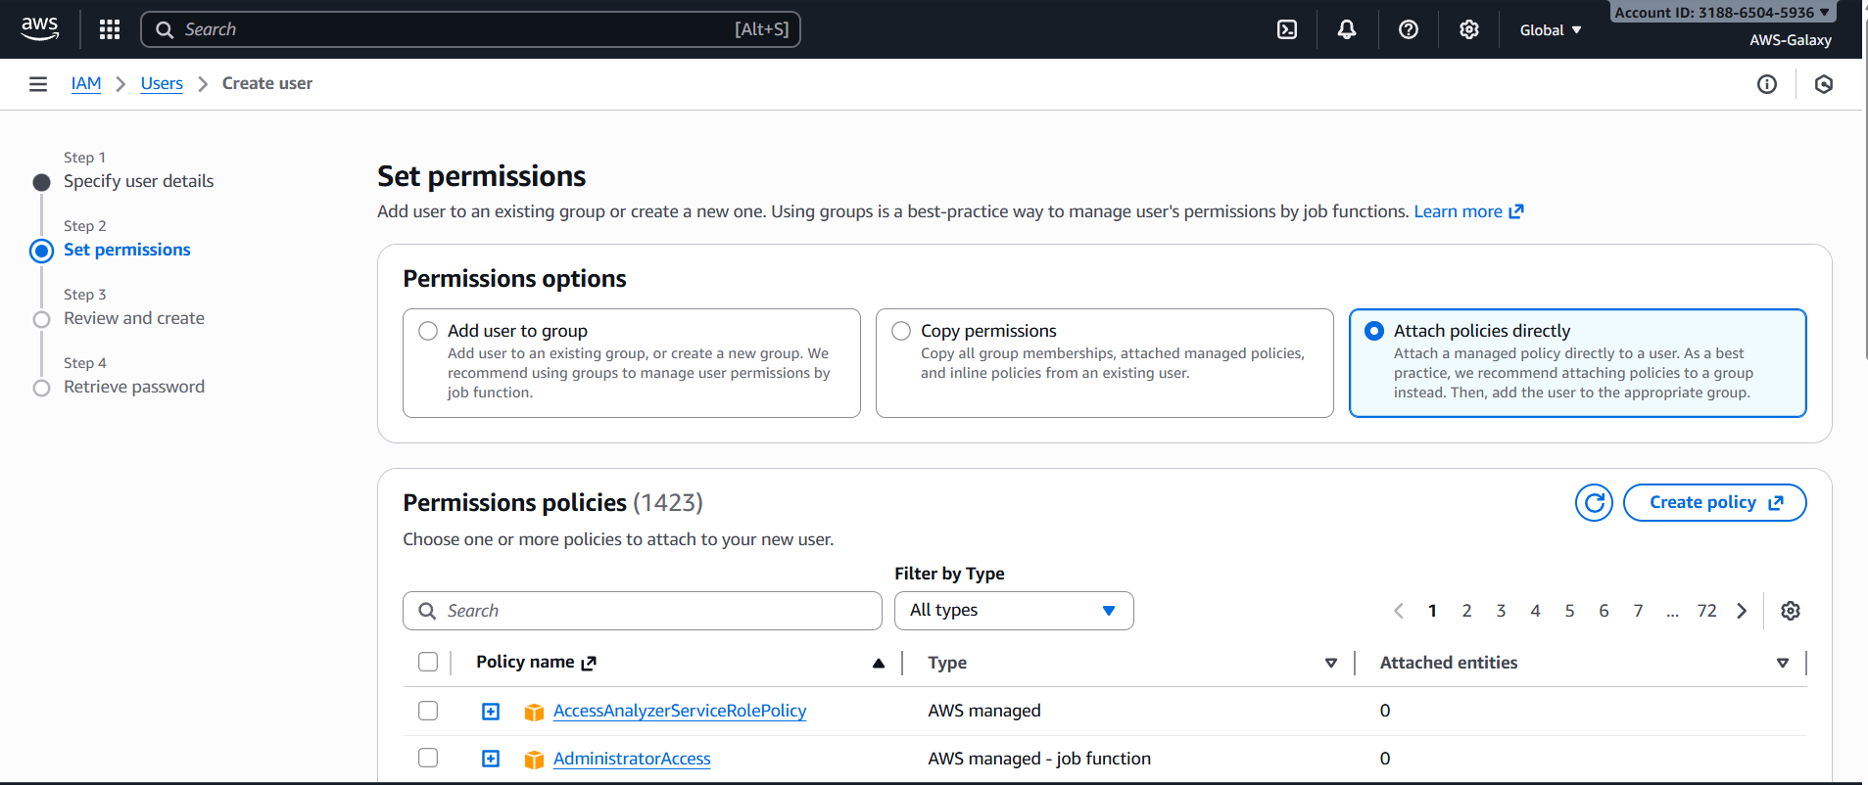
You can search service there select policy.
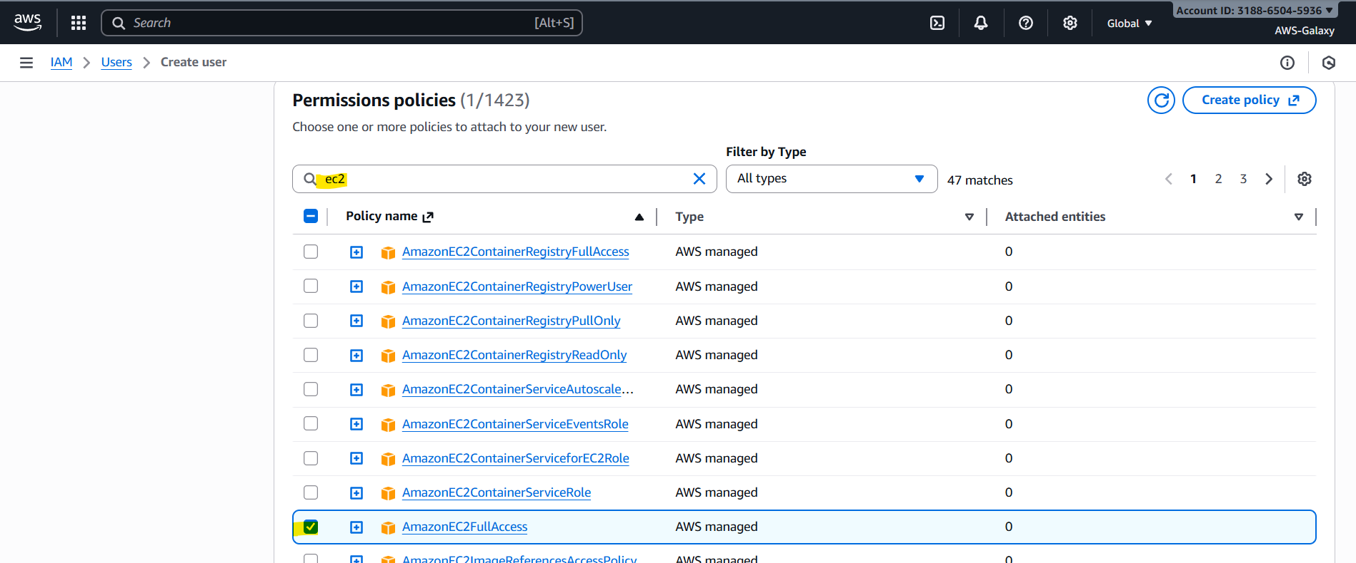
Once you click on next you will see our user will get 2 permissions 1 which we selected and other 1 they are giving by default the check box is check. Then click on create user.
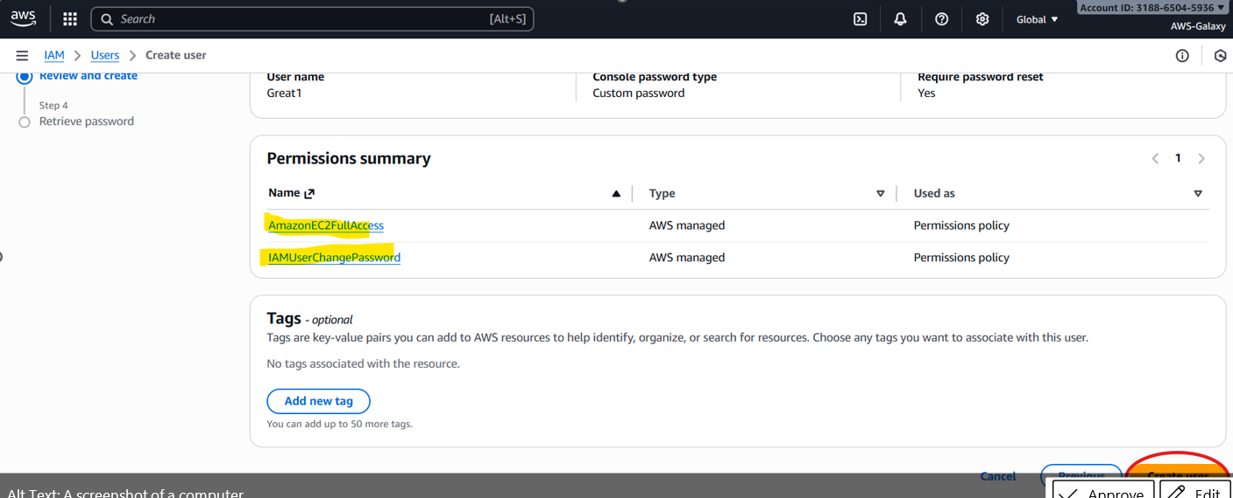
Our user will get created.
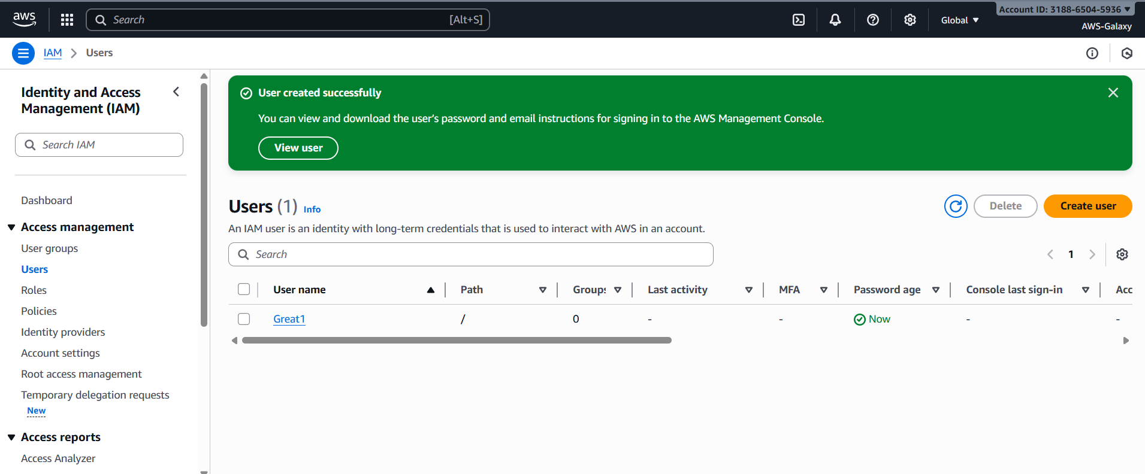

Now we will create one more user without selecting “Users must create a new password at next sign-in – Recommended”. At the end you will see this user only will have 1 permission which I am proving s3 full access. 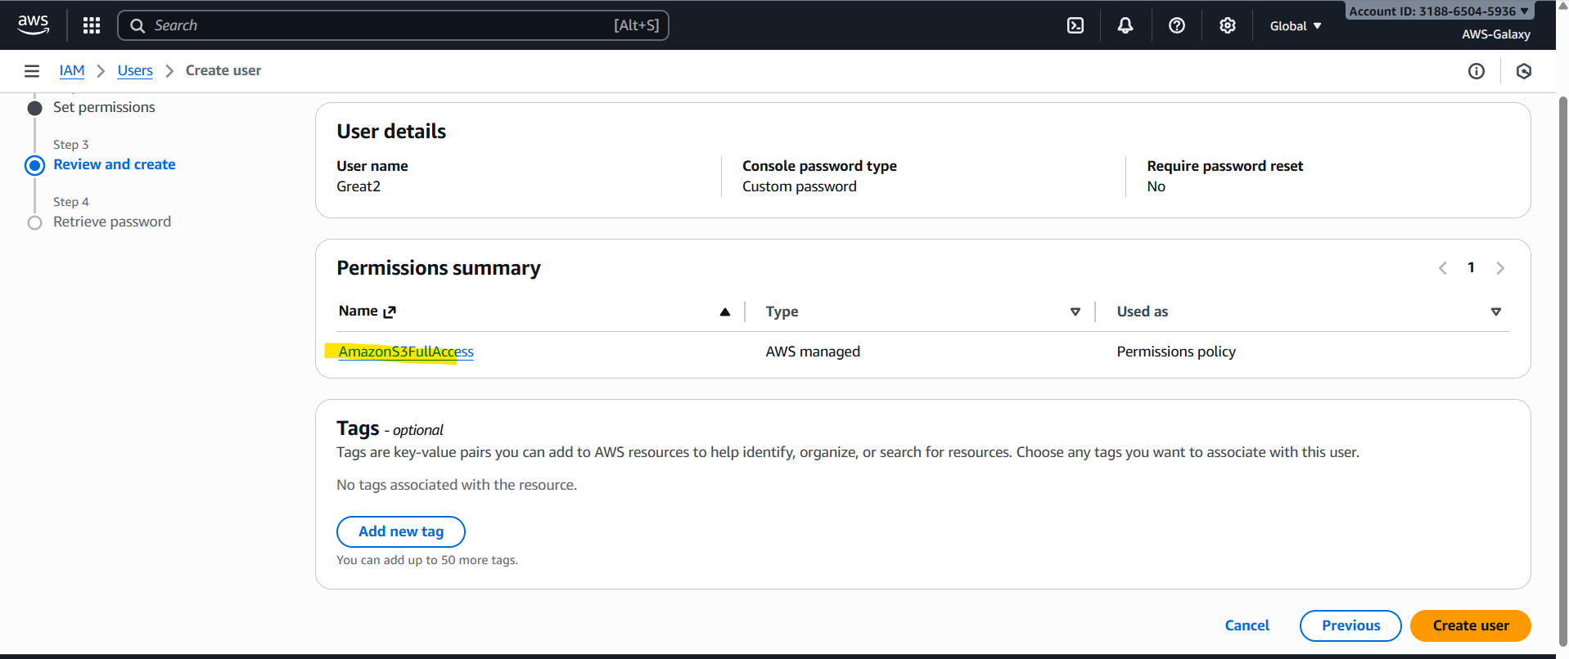
When we try to login this user you will see “user can’t change the password”. You have to use provided custom password only to login.

How to login to IAM user?
Select login as IAM user.
It will ask for account Id.
You have to provide your account Id of root account.
Then is Username and password provide the given username and password which you provided while creating user.

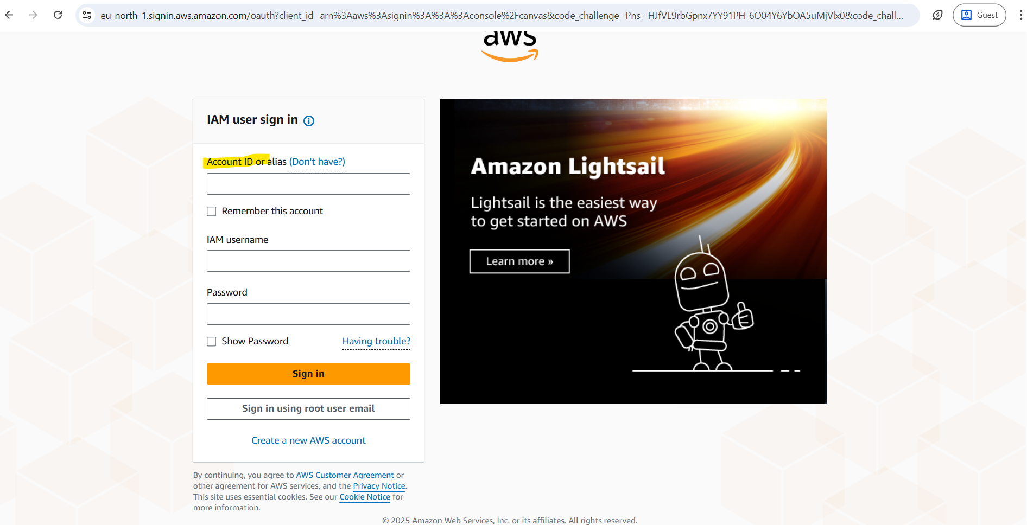
Once you click on sign in it will redirect you to the page where it will ask you to create new password as you have selected checkbox and gave permission to change password.
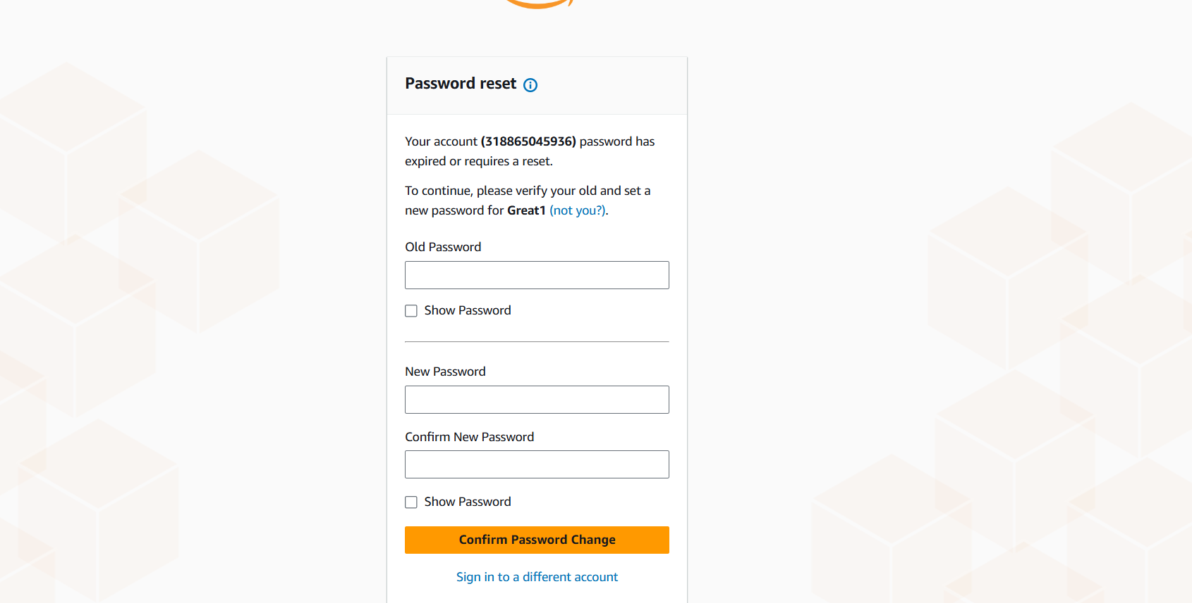
You can change your password by providing details. You will get a message like “Password reset successfully”. You will logged in to Great1 IAM user
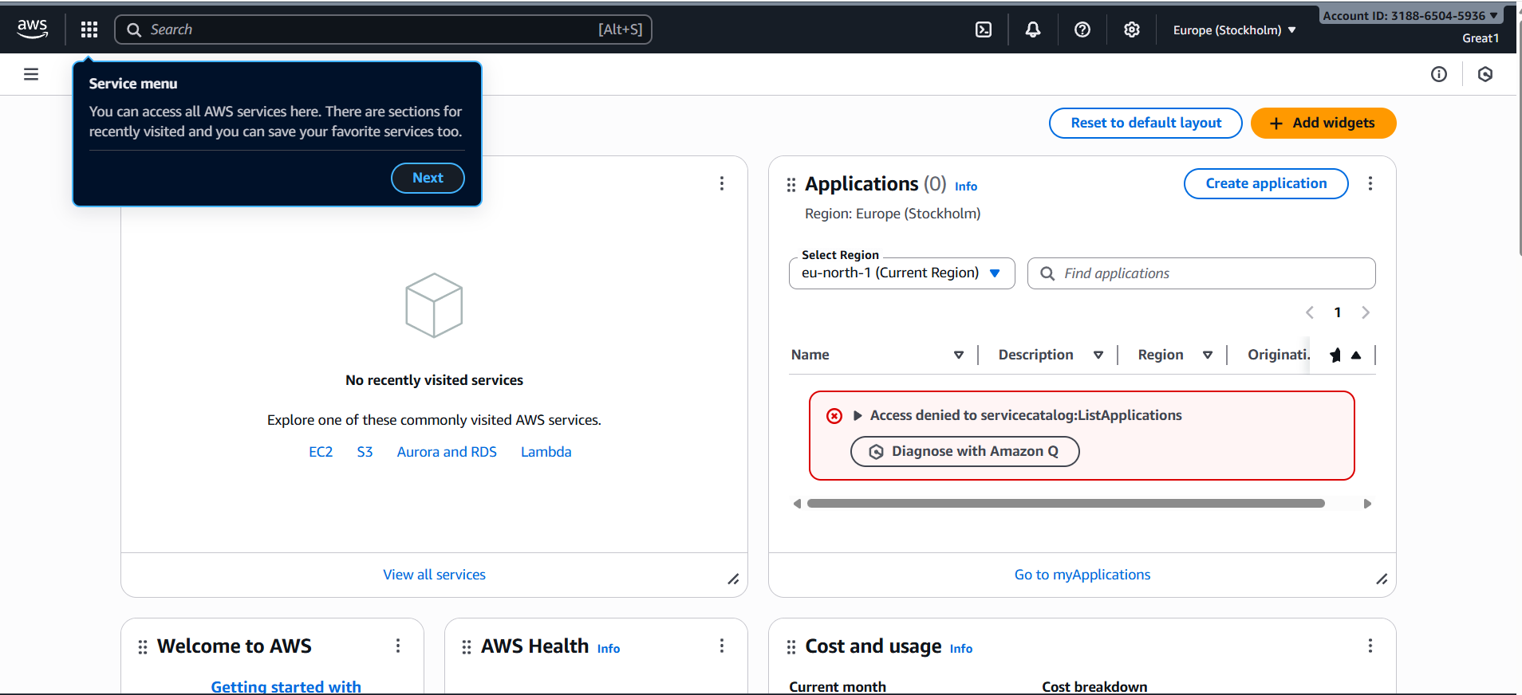
Follow the same process for other user but for that one you will not get option to reset option as we did not give permission.
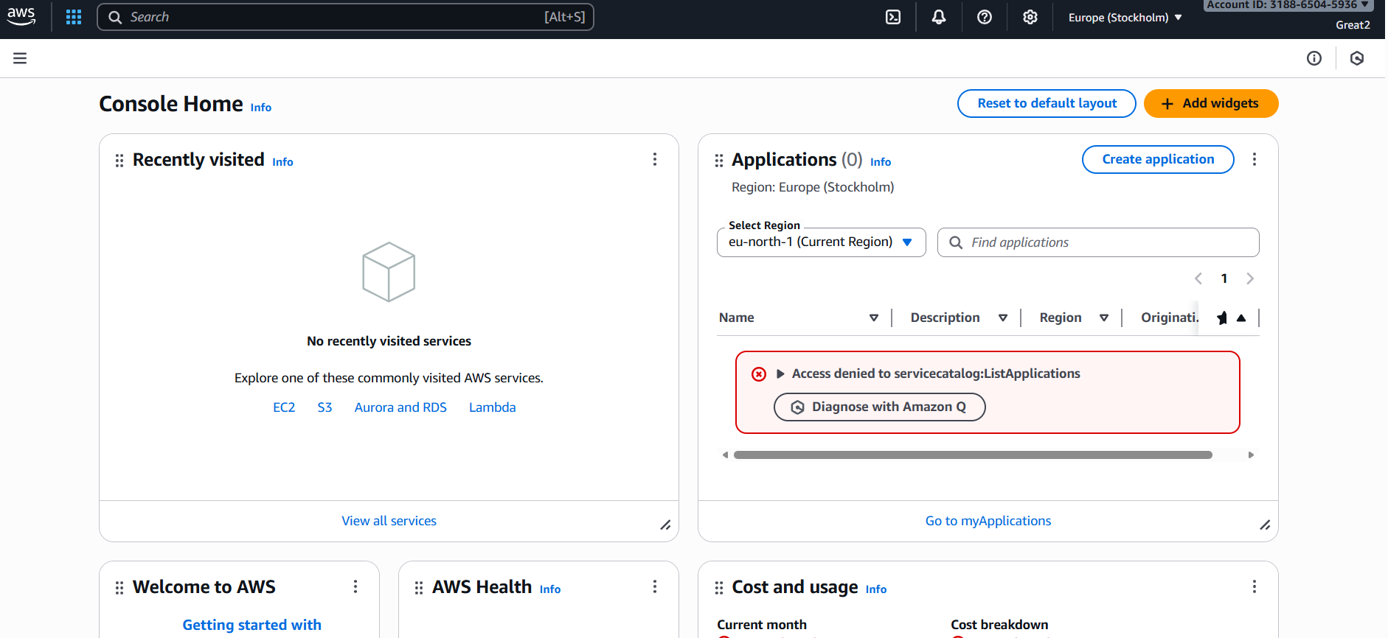

We can also provide below highlighted url as well to the user to login.
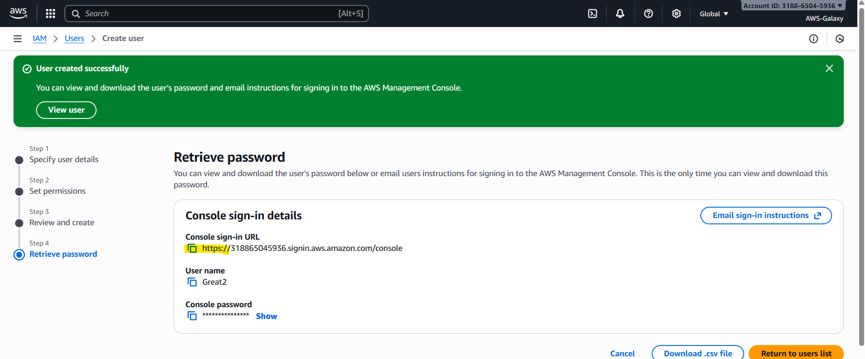
Whenever we are login to IAM user we need to provide account number with this url it will take account number from the url. You no need to enter account number manually.
You will get this url after creating user as well.
From user list select the particular user go to security credentials
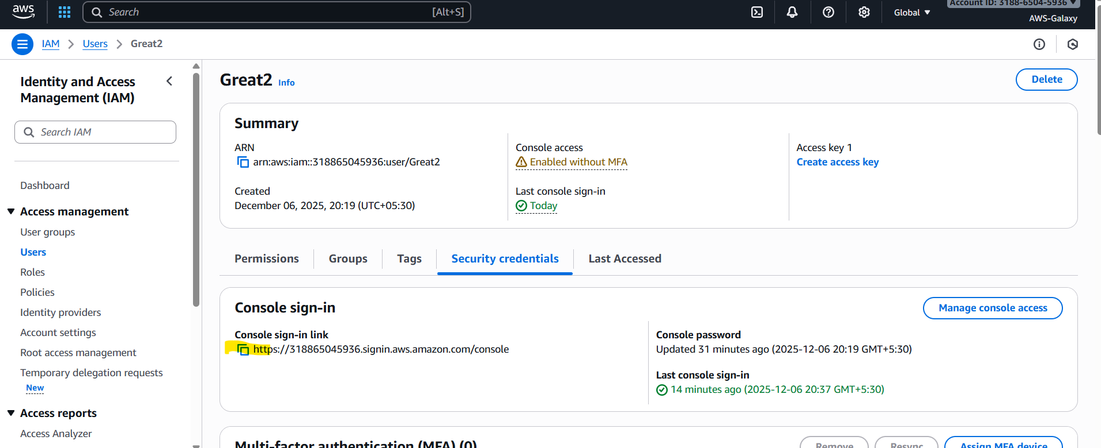

Now we will verify whether our user will be able to access the services which we have given access to them.
Now will create one EC2 machine using root user. Can our both IAM users will see this EC2 machine?
Our Great1 user will able to see this EC2 machine. As we have give EC2full access t this user.
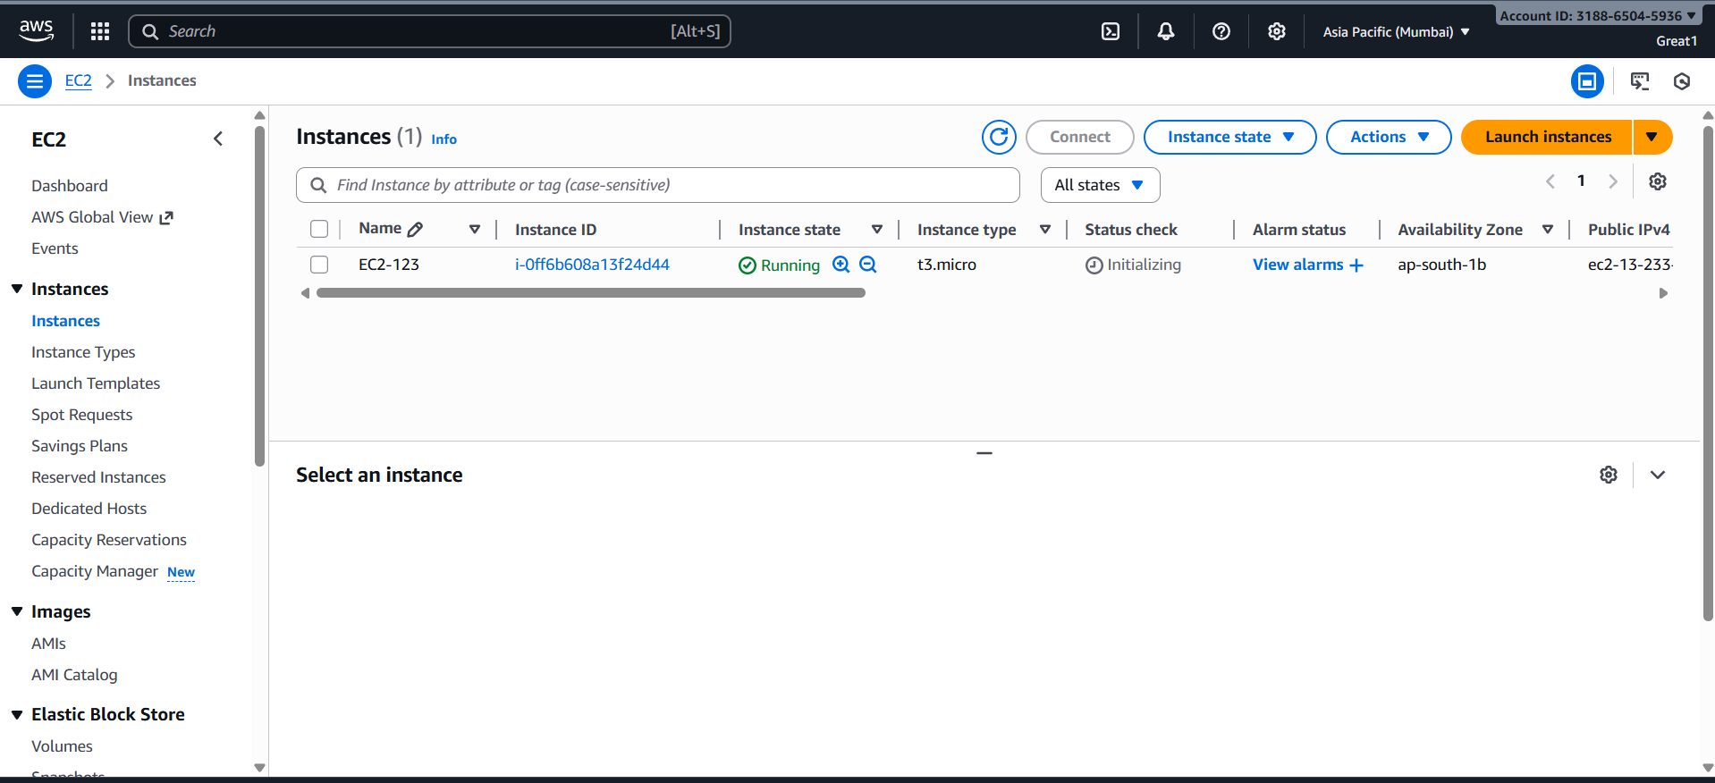
Now verify whether our Great2 user will access this EC2 machine. For Great2 user you will get an error message. Great2 user we did not give access to EC2 service so we can not access the services which we did not give permissions.
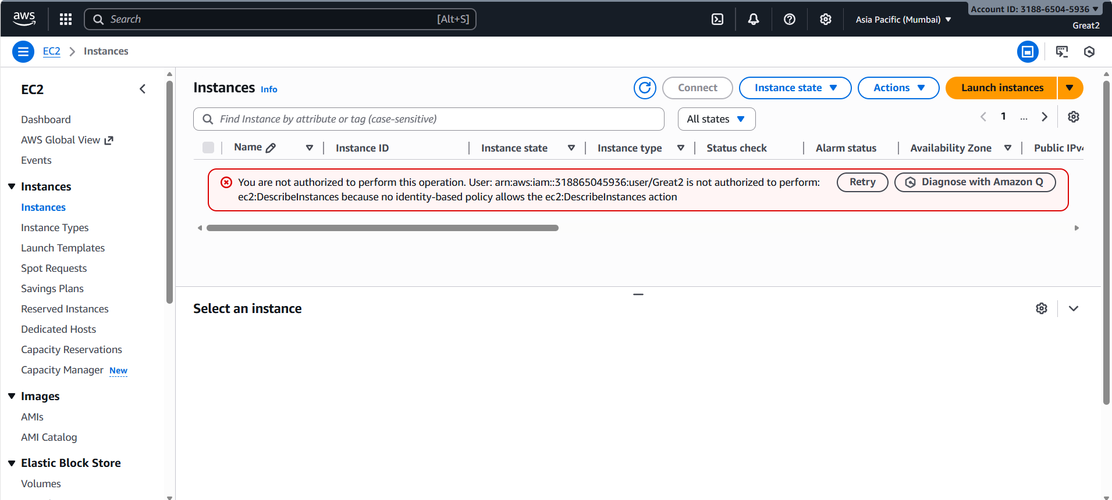

Note: Whatever work done by IAM user can be seen by Root user bcz it is having full permissions but to view the work done by Root user that IAM user need that particular permissions.

Now we will create bucket using IAM user. Verify whether our root user will able to see that or not.
You can see our root user able to see bucket created by our IAM user.
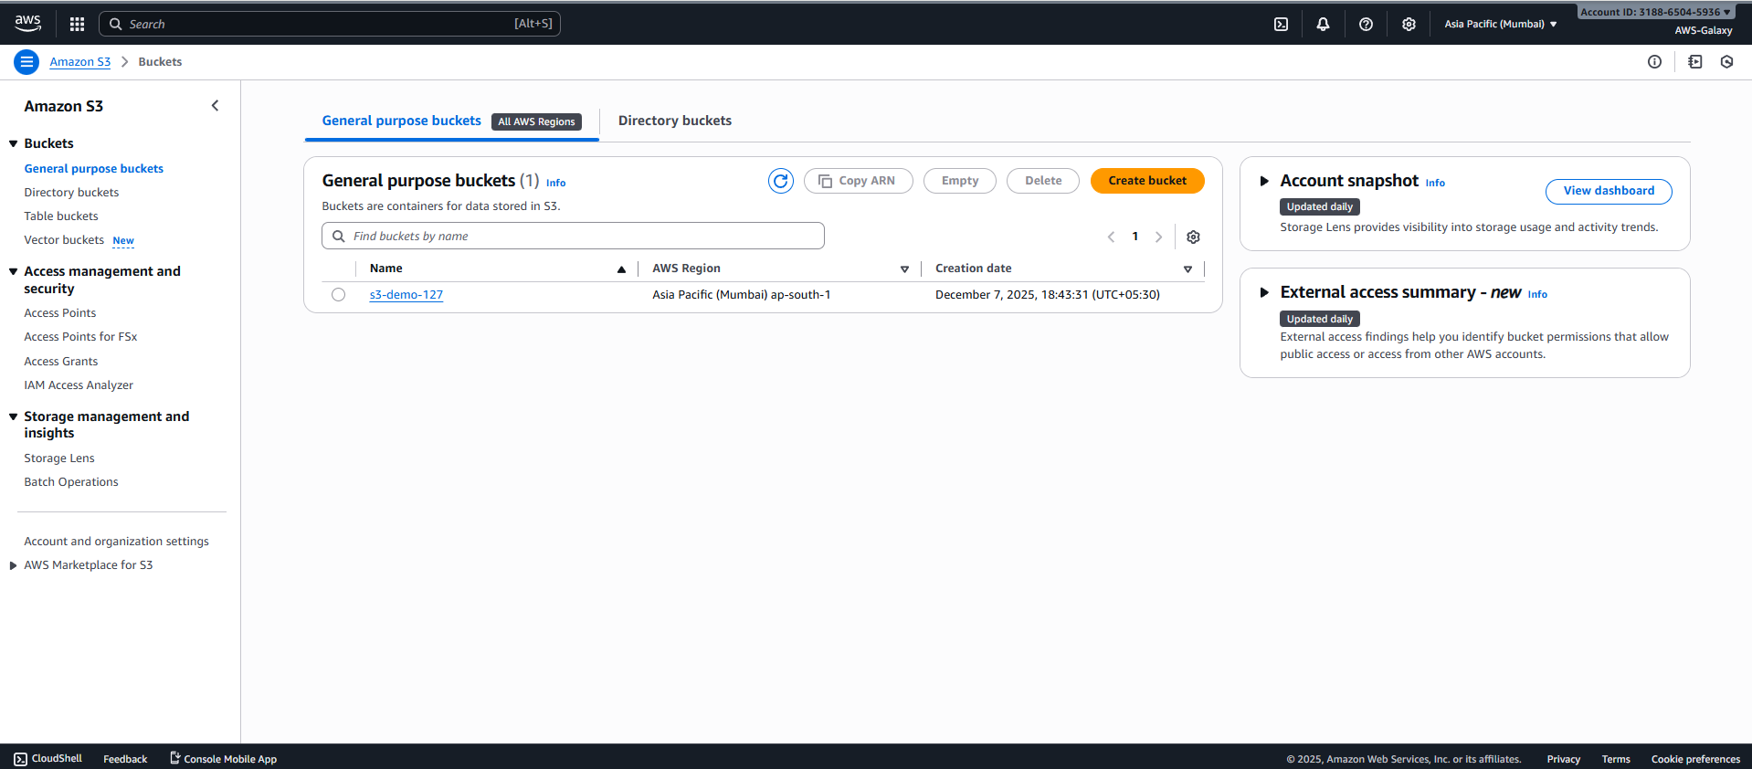

Great1 IAM user cannot see s3 bucket created by Great2 user as we did not give s3 permission to our Great1 user.

In organization we will not work as a root user. We will work as a IAM users. Whatever service access we are having those services only we can access.

Groups & Attach policies
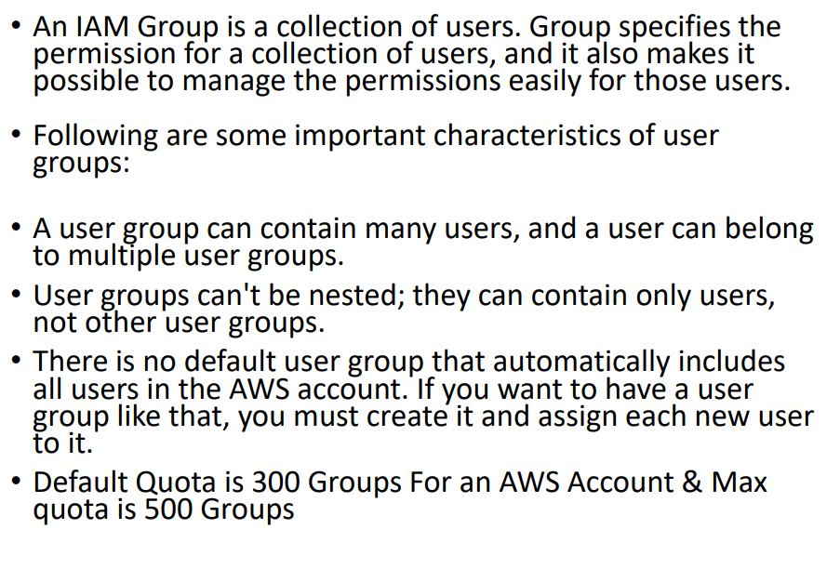
With the help of group we no need to give permission one by one. Once the user added in group that user will get all the permission assigned to that group.
We can maintain separate group for developer, taster and other roles..

How to create User Group?
Go to IAM service Select User Group Create Group
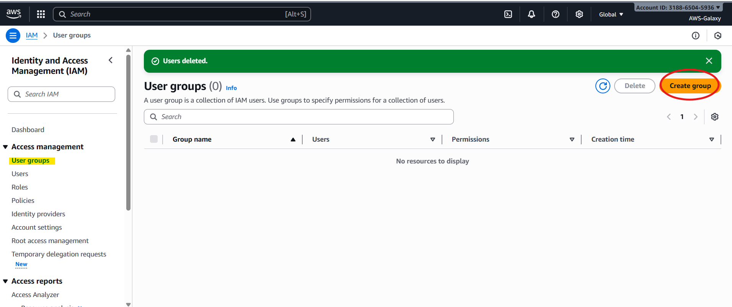
Give name to your group. While creating group you can add users if users already exists.
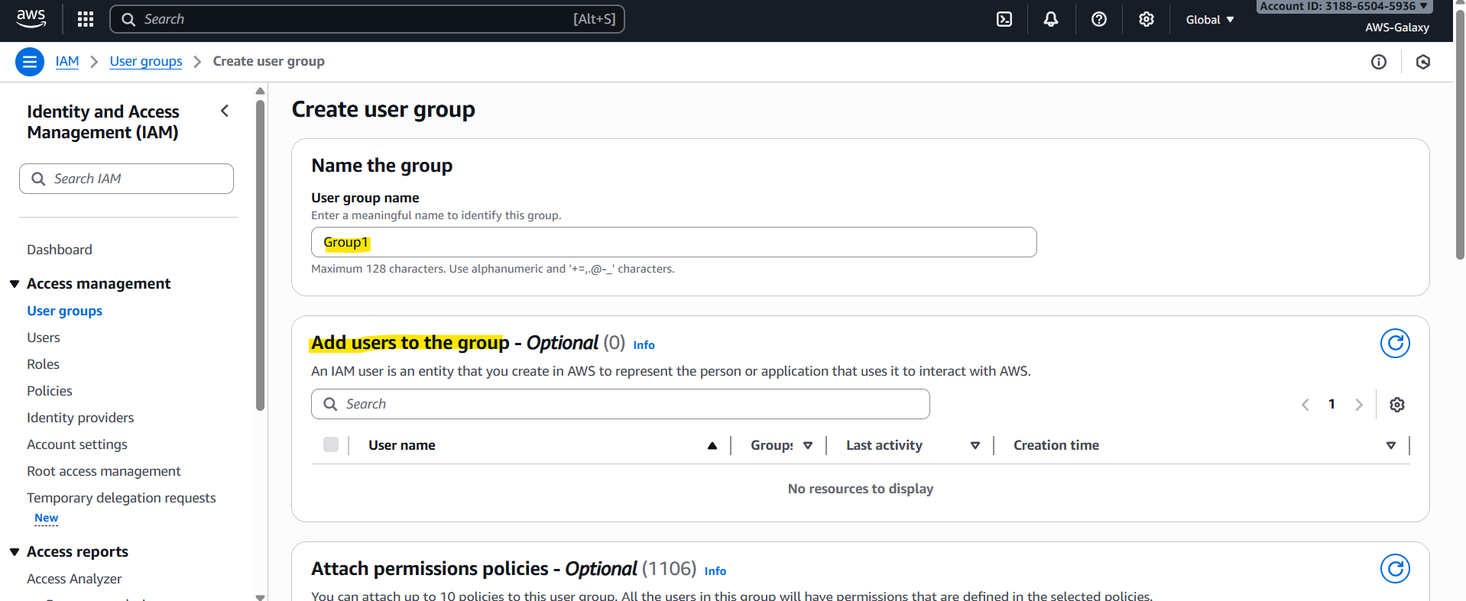
From attach permissions policies we can add whatever permissions we want to assign to that group. We can attach 10 policies to this user group. All the user within this group will have all the selected policies/permissions given to this group.
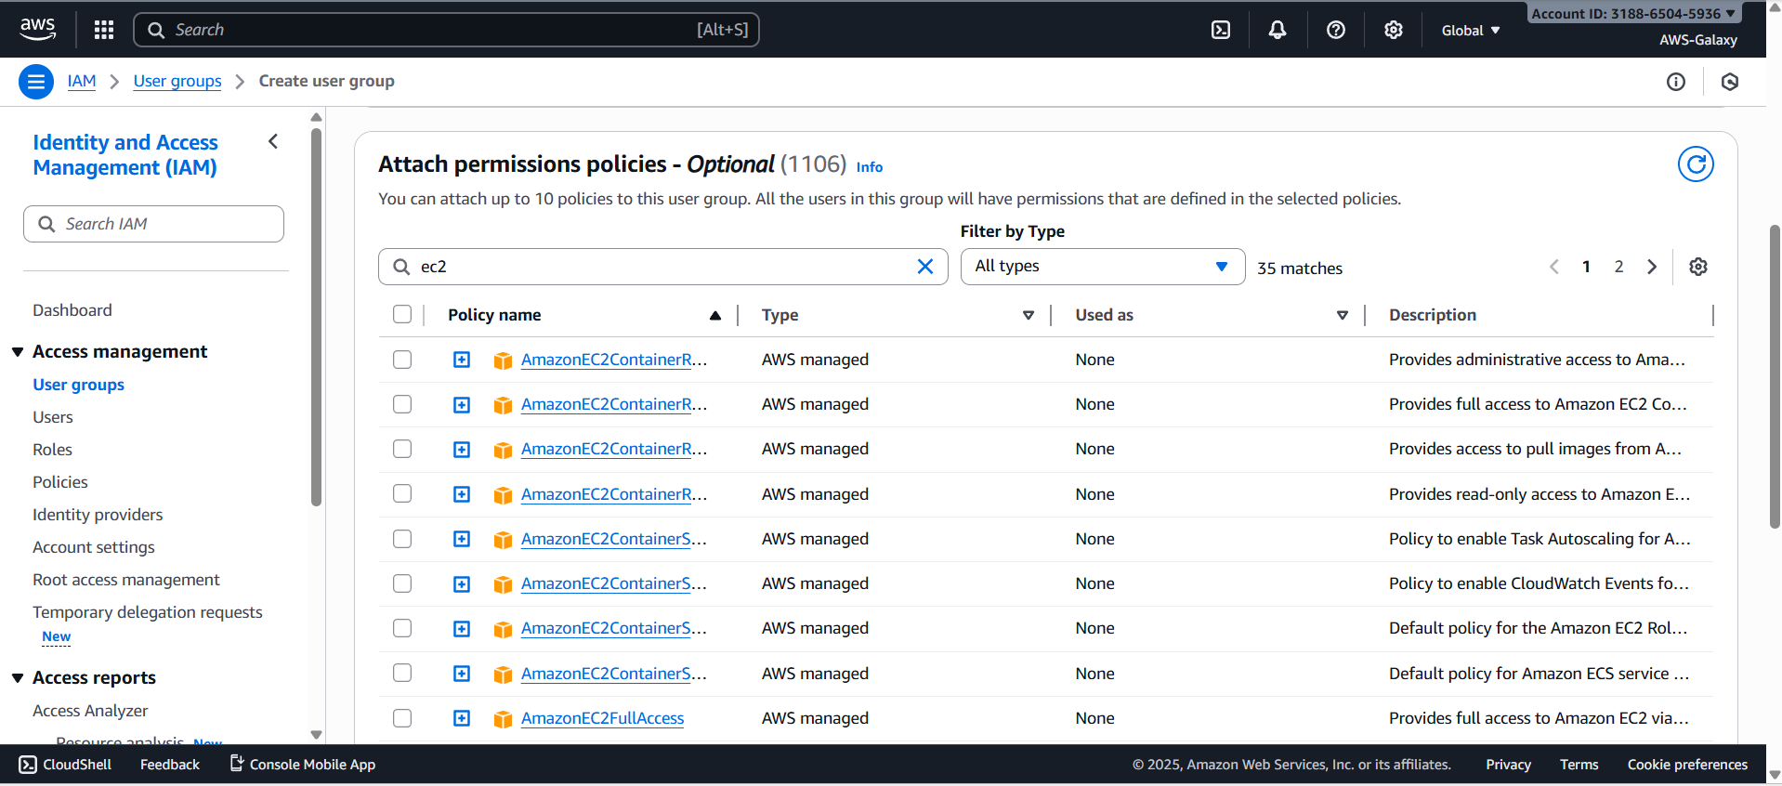
Click on create user group. 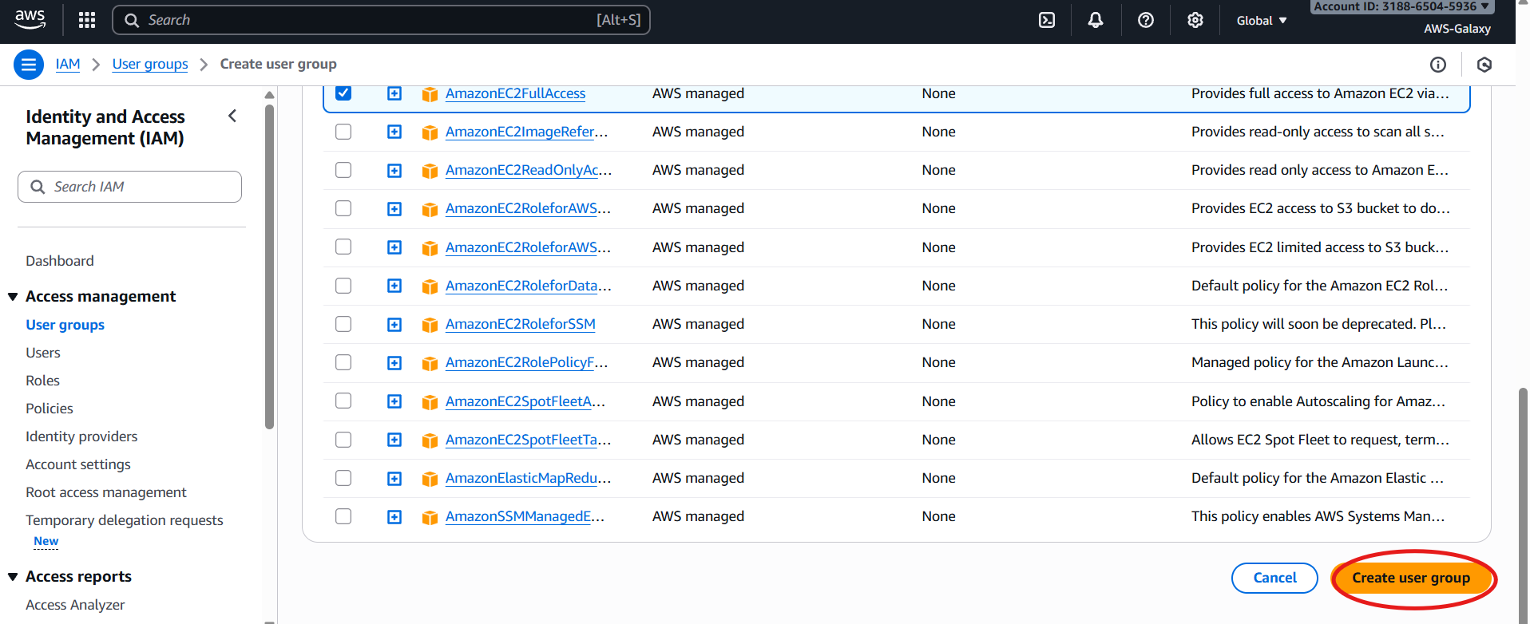
You can see the group created under User Groups
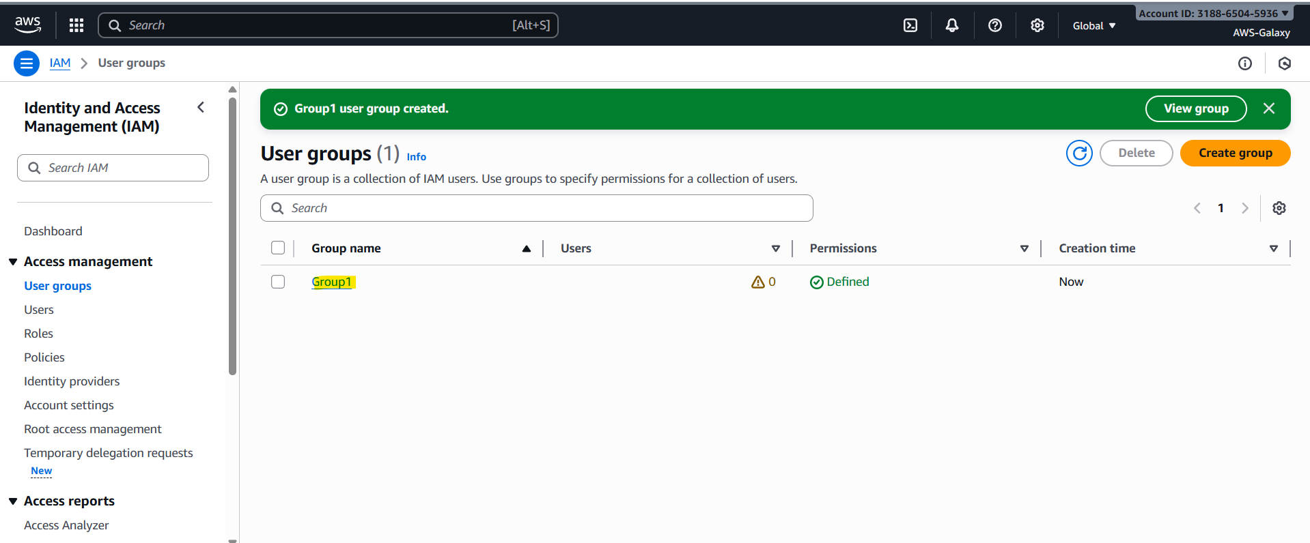

Now we will create one user and add that user to this group
To add user to that group you have to select “Add user to group” option while creating group. While selecting option for giving permission. So you user will get the permissions assigned to that particular group. Here you can see we have give ec2 permission to the group which we created that got assigned to this user.
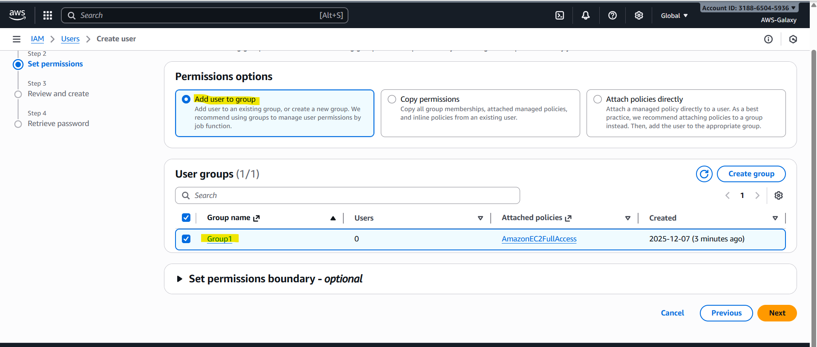
Here in permission summary you can see permission given to that user
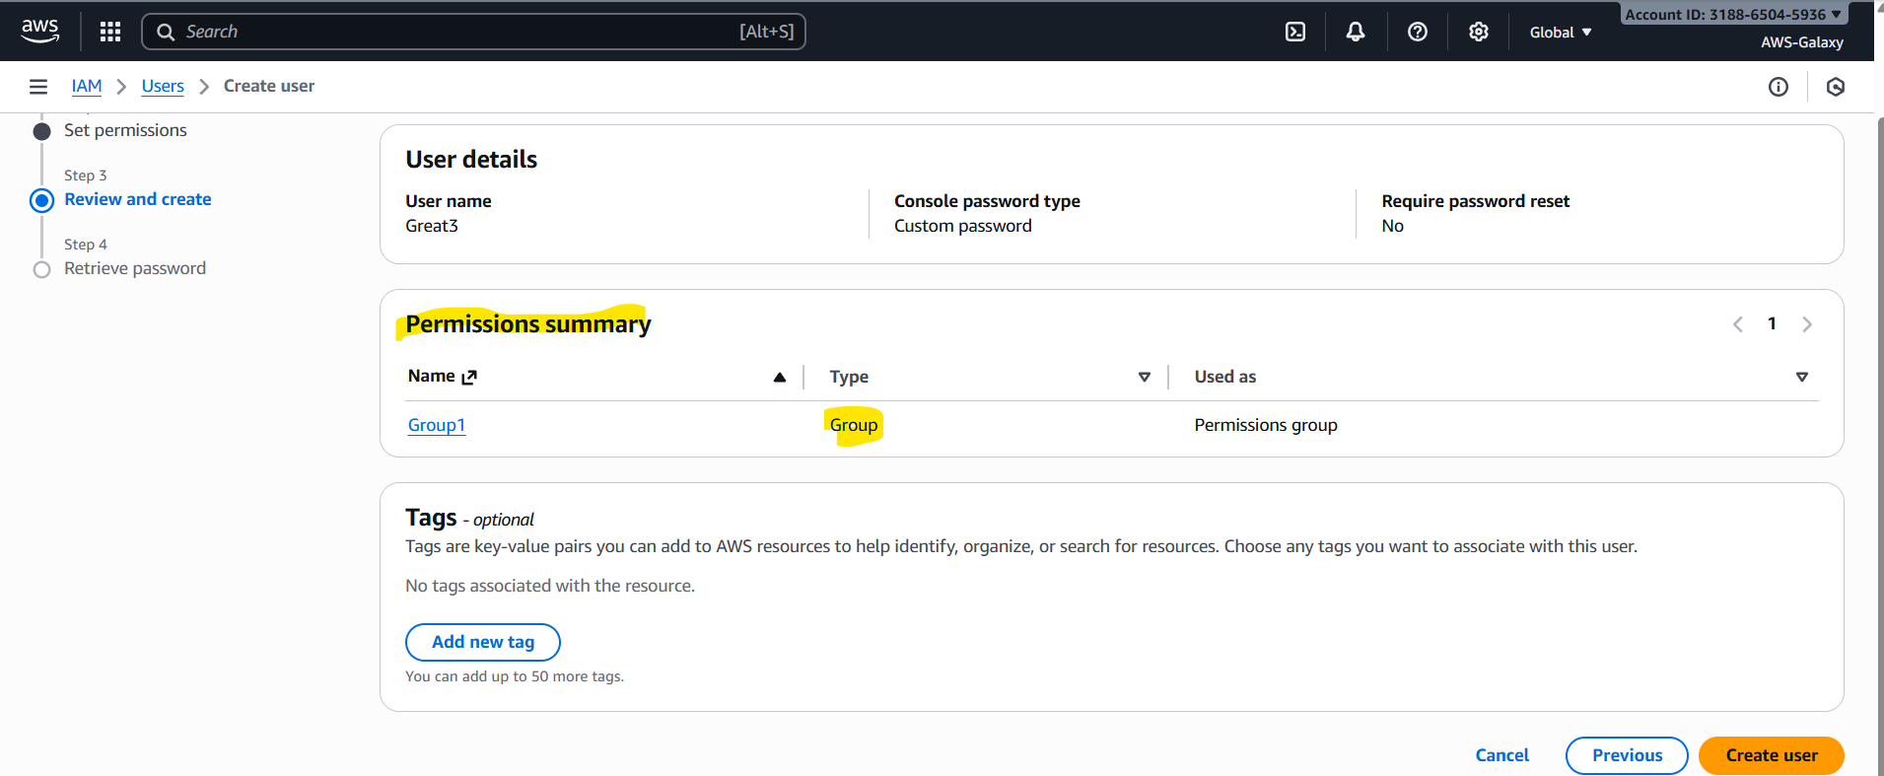
Note: For giving permission while creating user you can select only one option from this 3 options. Once user is ready if you want to add permissions you can add but while creating you have to select only 1 option from 3 option(Add user to group, copy permission, attach policies directly).
As we have given EC2 access to that group Great3 user cannot work on s3 Service
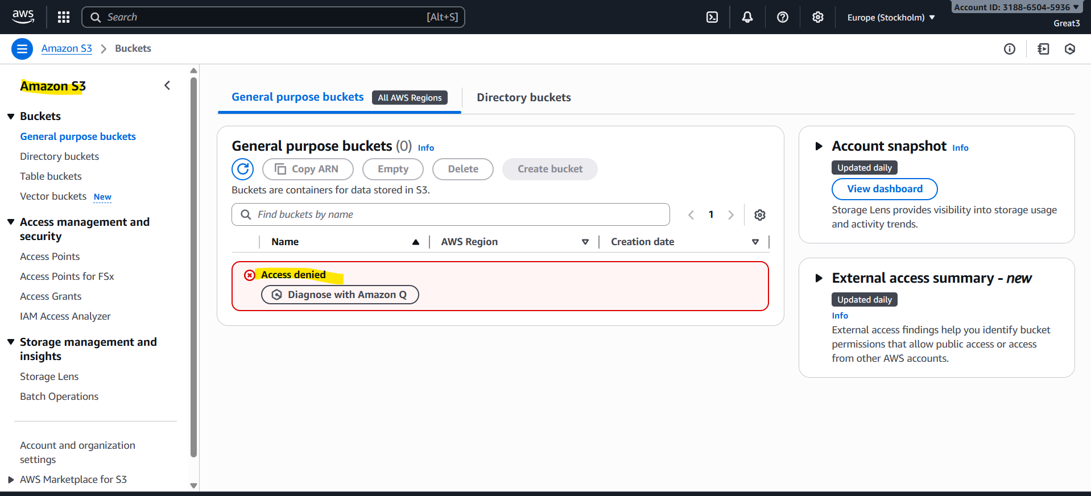
He can happily play with EC2 service.
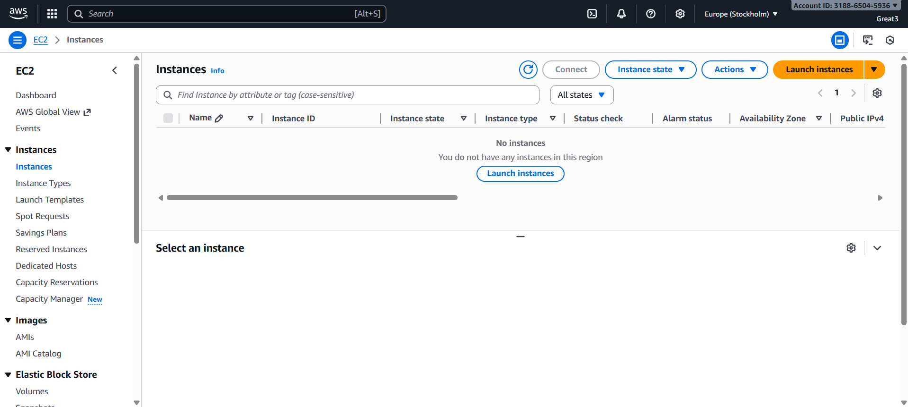
We can add or remove user from group at any time.
To remove user you have select that particular group and click on user and then click on remove.
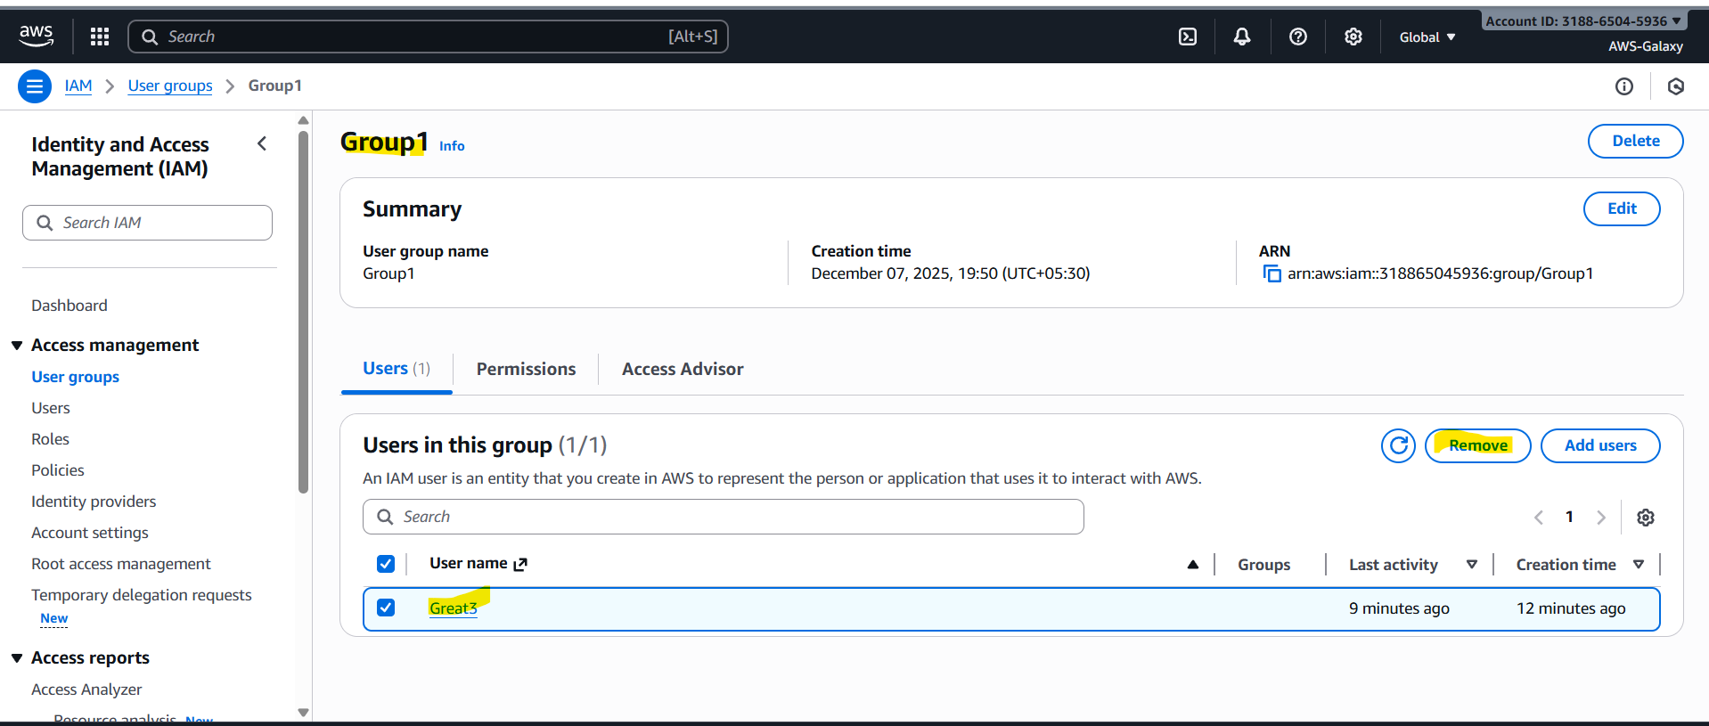
To add user to group select group click on add users select user click on add.
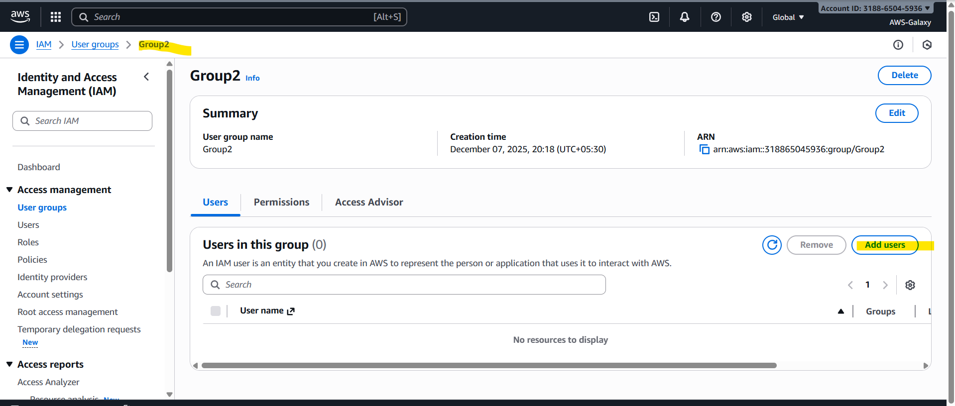
Now this Great3 user will have permission of Group2
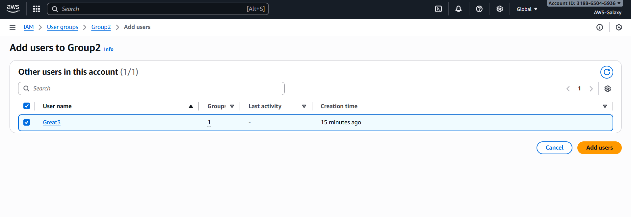

How to add more permissions to group after creation of group?
Select group go to permissions add permissions attach policies select the policy.
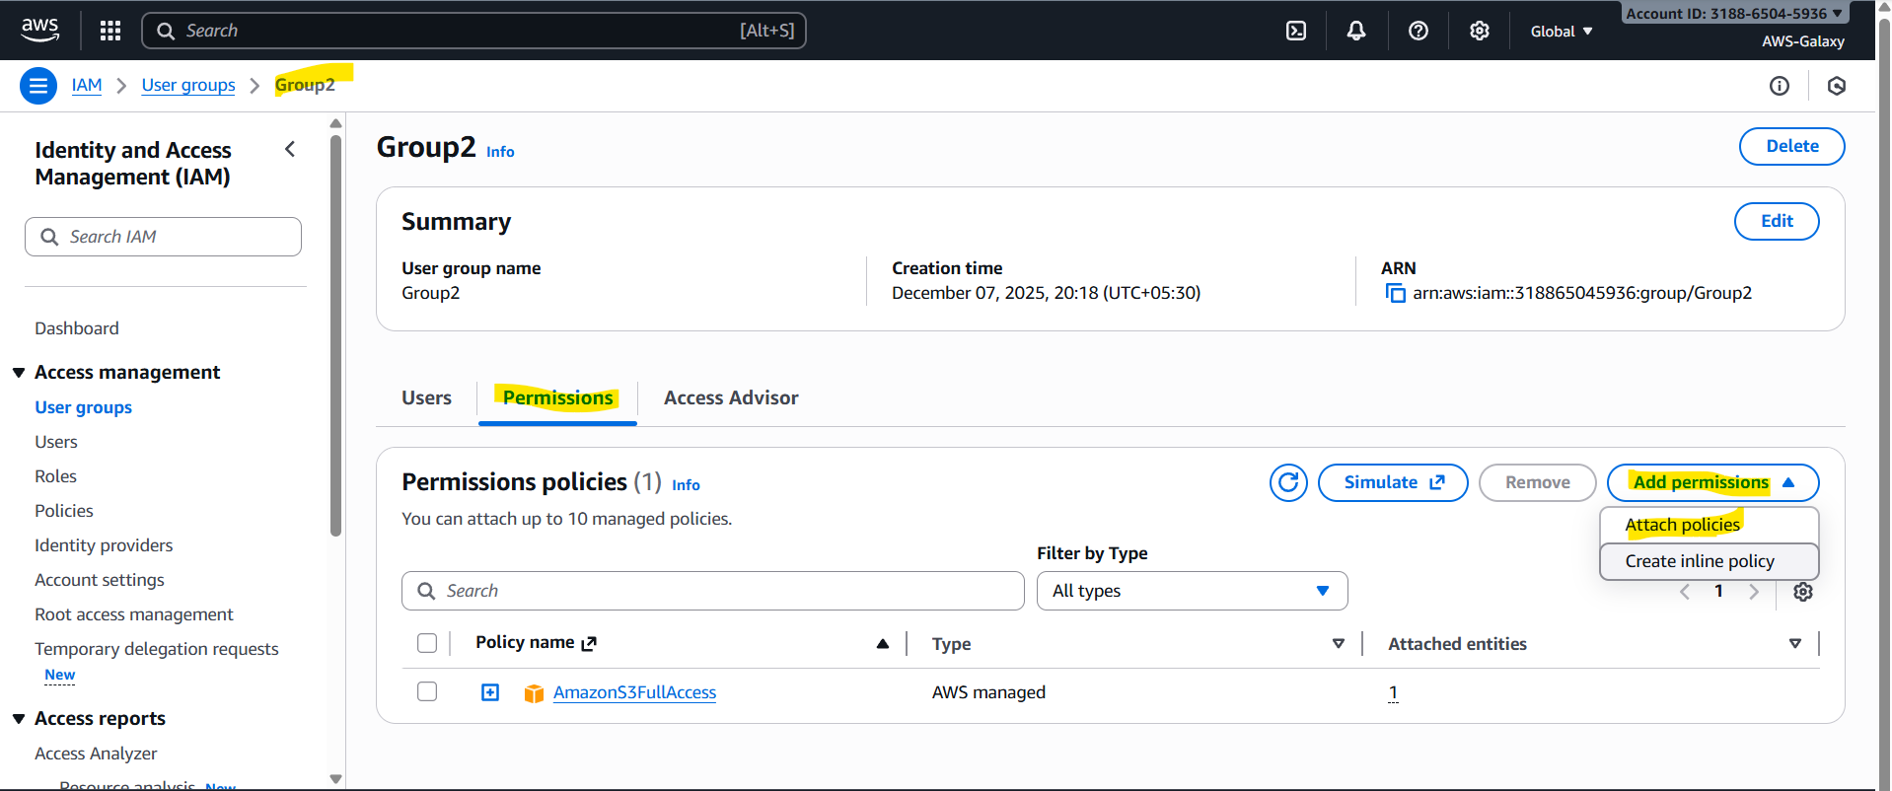
Now you can see we have attached ec2 permissions to this group
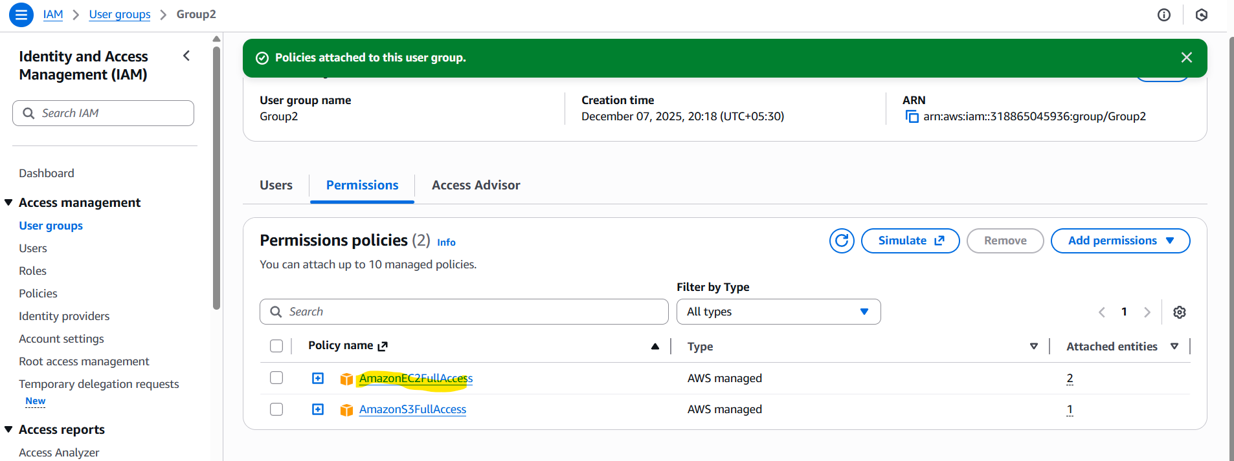

AWS CLI
CLI stands for Command Line Interface. It is tool used to manage AWS services using this we can control multiple AWS services from command line. For cli we have to use commands given by AWS.

